Experiment No.8
Name :-Shivani Kolekar
Roll No:-24141031
Batch:-I2
Title:- All pair shortest path Problem using Floyd's algorithm.
Programm:-
#include <stdio.h>
#define INF 99999
#define V 4 // Number of vertices
void floydWarshall(int graph[V][V]) {
int dist[V][V];
// Initialize distance matrix same as input graph
for (int i = 0; i < V; i++)
for (int j = 0; j < V; j++)
dist[i][j] = graph[i][j];
// Floyd-Warshall algorithm (Dynamic Programming)
for (int k = 0; k < V; k++) {
for (int i = 0; i < V; i++) {
for (int j = 0; j < V; j++) {
if (dist[i][k] + dist[k][j] < dist[i][j])
dist[i][j] = dist[i][k] + dist[k][j];
}
}
}
// Print the shortest distance matrix
printf("\nAll Pairs Shortest Path Matrix:\n");
for (int i = 0; i < V; i++) {
for (int j = 0; j < V; j++) {
if (dist[i][j] == INF)
printf("%7s", "INF");
else
printf("%7d", dist[i][j]);
}
printf("\n");
}
}
int main() {
int graph[V][V] = {
{0, 5, INF, 10},
{INF, 0, 3, INF},
{INF, INF, 0, 1},
{INF, INF, INF, 0}
};
printf("Floyd's Algorithm - All Pair Shortest Path\n");
floydWarshall(graph);
return 0;
}
Output:- 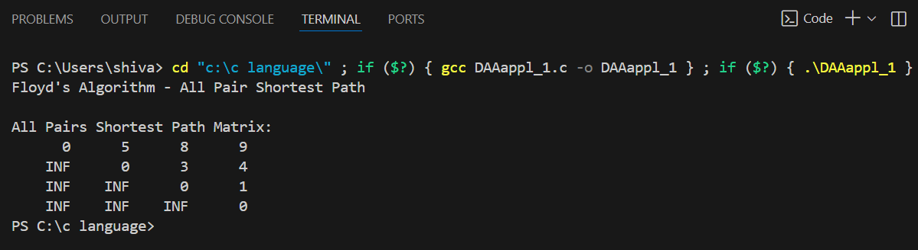

Complexities of Floyd’s Algorithm (in short):
- Time Complexity: O(V3)O(V^3)O(V3)
→ Three nested loops for all pairs and intermediate vertices.
- SpaceComplexity: O(V2)O(V^2)O(V2)
→ Stores a distance matrix of size V×VV \times VV×V.

Applications of Floyd’s Algorithm
1. Network Routing
- Used to find the shortest communication paths between all nodes in a network.
- Example: Internet routing protocols, packet switching networks.
2. Transportation and Navigation Systems
- Helps determine shortest travel routes between all cities/intersections.
- Used in:
  - GPS navigation systems
  - Airline and railway route planning
3. Social Network Analysis
- To find the degrees of separation or closeness between users (nodes).
- Example: “Friend-of-a-friend” connections on social platforms.
4. Urban Traffic Management
- Used to plan and optimize traffic flow by computing shortest paths between all junctions in a city map.
5. Game Development and AI Pathfinding
- Determines minimum movement costs between all positions or waypoints on a game map.
6. Telecommunication Systems
- Used in network optimization — finding least-cost communication paths between switches or routers.
7. Project Scheduling
- Helps analyze critical paths or shortest completion times in task dependency graphs.

Conclusion:-Floyd’s Algorithm efficiently finds the shortest paths between all pairs of vertices using Dynamic Programming, with a time complexity of O(V³) — simple and powerful for small or medium-sized graphs.

